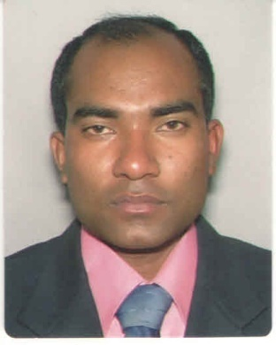
Gazi Mahbubur Rahman

Mailing address:
Chapatala, Jhikargacha, Jessore,Bangladesh-7420
Cell: 01971150512
E-mail: gmrtuhin@gmail.com

Career Objective:
Attainment of maximum value through offering well merited performance and interchanging benefit with the organization. I want to be a perfect working hand of the organization to attain its goal and to build up my career.

Academic Profile:

Secondary School Certificate(S.S.C)
Name of Institute : Jhikargacha M.L Govt High School
Passing Year : 2004
Group : Science
Board : Jessore
Result : 4.50 (G.P.A)

Higher Secondary Certificate(H.S.C)
Name of Institute : Dr. AbdurRazzak Municipal College
Passing Year : 2007
Group :Science
Board : Jessore
Result : 3.60 (G.P.A)

Graduate Diploma:
Graduate Diploma In Hospitality And Tourism Management
Qualification level : NQF level 6
Awarding Body : NCFE
Course Start Date : 22 November 2010
Duration of Course : Three Years
Course end date : 30 September 2013
Study Center : London Metrocity College, 153-159 Bow Road, London E3 2SE

B.Sc (Hon’s)
International Hospitality And Tourism Management
Name of Institute : University Of Sunderland
Year of Exam : 2013-2014
Result : 2nd Class (Marks-59.60%)

Experiences:
Tesco Super Store- CA( Customer Service Assistance) from 2011-2015 Martin Brawchette, Personnel Manager, Hingham’s park Tesco superstore, 405 Larkshall Rd, London, E4 9EF, United Kingdom. Tell : 0044-07977813340
Interne:
Hotel Marriott International, Canary Warf sponger by University Of Sunderland
Project Coordinator :
Chapatala Kirishis Utpadonmukhi Samobai Semite, Jhikargacha, Jashore, Bangladesh
Computer Skills:
Operating System: MS Windows XP
Applications: Ms Word & Internet Browsing
Training For computer Course : IGA( Computer Course),Khulna Zonal Co-Operative Society, Khulna, Bangladesh.
Interest and Hobbies :
- Reading Books
- Traveling
- Playing Chess
- Listening Music
Personal Information :
Father’s Name : Md. Waliar Rahman( Freedom Fighter, Sector-8)
Mother’s name : Mariam Akther
Religion : Islam
Nationality : Bangladeshi
Date of Birth : 06/01/1989
Marital Status : Unmarried
Permanent Address : Vill-Chapatala, P.O- Jhikargacha, P.S- Jhikargacha, Dist- Jessore.
Reference :
DirisaMulindwa
PhD
Programme Leader
Tourism and Hospitality
Business and Law Faculty
University Of Sunderland
Tel: (0044) 02075317333
Mobile: (0044) 07912436591
E-mail : Dirisa.mulindwa@sunderland.ac.uk

Dr. Claudia Sima
Visiting Lecturer University of Westminster
Lecturer in Tourism and Assistant Programme Manager University Of Sunderland London Campus Mobile: (0044) 07510895217
E-mail :claudiasima85@yahoo.com

Declaration :
I am Gazi Mahbubur Rahman Hereby Declare that the above Information is to and correct to the best of my Knowledge.

Signature

…………………………..........

Gazi Mahbubur Rahman

